1. Write a Shell program to check the given number is even or odd.

echo "Enter a number:"
read number
if((number%2==0));then
echo"$number is even"
else
echo "$number is odd"
fi
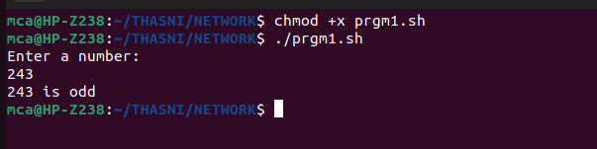

2. Write a Shell program to check a leap year.

#!/bin/bash
#author:Thasni Noufal
echo "enter a year:"
read year
if((year %4==0 &&(year%100!=0||year%400!=0)));then
echo "$year is leap year"
else
echo "$ year is not a leap year"
fi

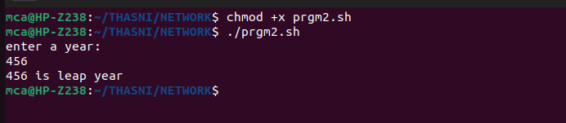

3. Write a Shell program to find the area and circumference of a circle.

#!/bin/bash
#author:Thasni noufal
echo "Enter the radius of the circle:"
read radius

# Calculate area
area=$(echo "scale=2; 3.14 * $radius * $radius" | bc)

# Calculate circumference
circumference=$(echo "scale=2; 2 * 3.14 * $radius" | bc)

echo "Area of the circle with radius $radius is: $area"
echo "Circumference of the circle with radius $radius is: $circumference"

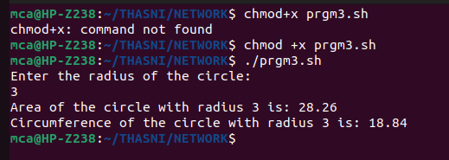

4. Write a Shell program to check the given number and its reverse are same.

#!/bin/bash
#author:Thasni noufal
echo "Enter a number:"
read number

# Reverse the number
reverse=$(echo $number | rev)

# Check if the number and its reverse are the same
if [ "$number" = "$reverse" ]; then
echo "The number $number is a palindrome."
else
echo "The number $number is not a palindrome."
fi

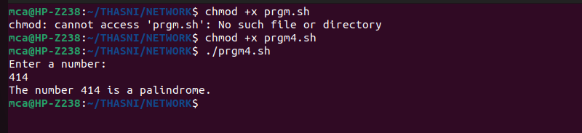

5. Write a Shell program to check the given string is palindrome or not.

#author:Thasni Noufal
#!/bin/bash
echo "Enter a string:"
read input_string
clean_string=$(echo "$input_string" | tr -d ' ' | tr '[:upper:]' '[:lower:]')
reverse_string=$(echo "$clean_string" | rev)
if [ "$clean_string" = "$reverse_string" ]; then
echo "The string '$input_string' is a palindrome."
else
echo "The string '$input_string' is not a palindrome."
fi

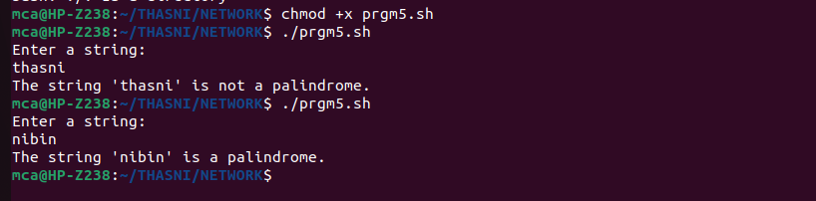

6. Write a Shell program to find the sum of odd and even numbers from a set of numbers.

#!/bin/bash
#author:Thasni Noufal
echo "Enter numbers separated by spaces:"
read -a numbers

# Initialize sums
sum_even=0
sum_odd=0

# Loop through the numbers and calculate sums
for num in "${numbers[@]}"; do
if [ $((num % 2)) -eq 0 ]; then
sum_even=$((sum_even + num))
else
sum_odd=$((sum_odd + num))
fi
done

echo "Sum of even numbers: $sum_even"
echo "Sum of odd numbers: $sum_odd"

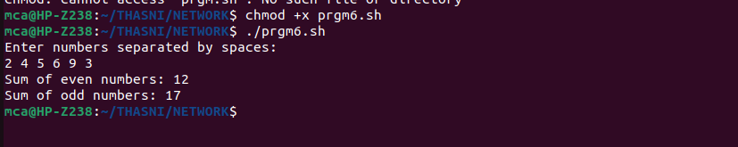

7. Write a Shell program to find the roots of a quadratic equation.

#!/bin/bash
#author:Thasni Noufal
echo "Enter the coefficients of the quadratic equation (a, b, c):"
read a b c

# Calculate the discriminant
delta=$((b*b - 4*a*c))

# Check the nature of roots based on discriminant
if [ $delta -gt 0 ]; then
root1=$(echo "scale=2; (-$b + sqrt($delta)) / (2*$a)" | bc)
root2=$(echo "scale=2; (-$b - sqrt($delta)) / (2*$a)" | bc)
echo "Roots are real and different."
echo "Root 1 = $root1"
echo "Root 2 = $root2"
elif [ $delta -eq 0 ]; then
root=$(echo "scale=2; -$b / (2*$a)" | bc)
echo "Roots are real and identical."
echo "Root = $root"
else
real_part=$(echo "scale=2; -$b / (2*$a)" | bc)
imaginary_part=$(echo "scale=2; sqrt(-$delta) / (2*$a)" | bc)
echo "Roots are complex and conjugates."
echo "Root 1 = $real_part + $imaginary_part i"
echo "Root 2 = $real_part - $imaginary_part i"
fi

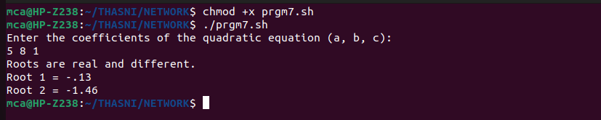

8. Write a Shell program to check the given integer is Armstrong number or not.

#!/bin/bash
#author:Thasni Noufal
echo "Enter a number:"
read number

# Calculate the number of digits in the given number
num_digits=${#number}

# Initialize sum
sum=0

# Temporary variable to store the original number
temp=$number

# Calculate sum of digits raised to the power of the number of digits
while [ $temp -gt 0 ]; do
digit=$((temp % 10))
sum=$((sum + digit ** num_digits))
temp=$((temp / 10))
done

# Check if the number is an Armstrong number
if [ $sum -eq $number ]; then
echo "$number is an Armstrong number."
else
echo "$number is not an Armstrong number."
fi

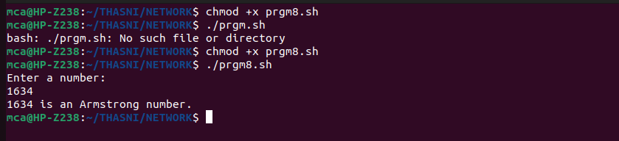

9. Write a Shell program to check the given integer is prime or not.

#!/bin/bash
#author:Thasni Noufal
echo "Enter a number:"
read number

# Function to check if a number is prime
is_prime() {
n=$1
if [ $n -le 1 ]; then
echo "$n is not a prime number."
exit
fi

i=2
while [ $i -le $((n / 2)) ]; do
if [ $((n % i)) -eq 0 ]; then
echo "$n is not a prime number."
exit
fi
i=$((i + 1))
done

echo "$n is a prime number."
}

# Call the function with the given number
is_prime $number

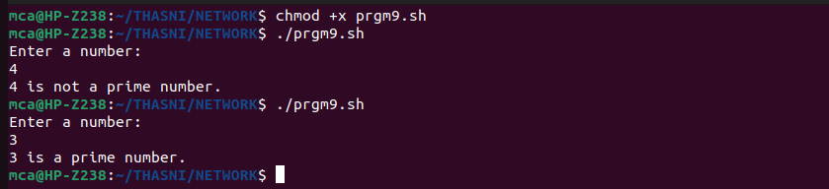

10.Write a Shell program to generate prime numbers between 1 and 50.

#author:Thasni Noufal
echo "Prime numbers between 1 and 50 are:"
for (( number=2; number<=50; number++ ))
do
flag=1

for (( i=2; i<=number/2; i++ ))
do
if [ $((number%i)) -eq 0 ]
then
flag=0
break
fi
done
if [ $flag -eq 1 ]
then
echo $number
fi
done

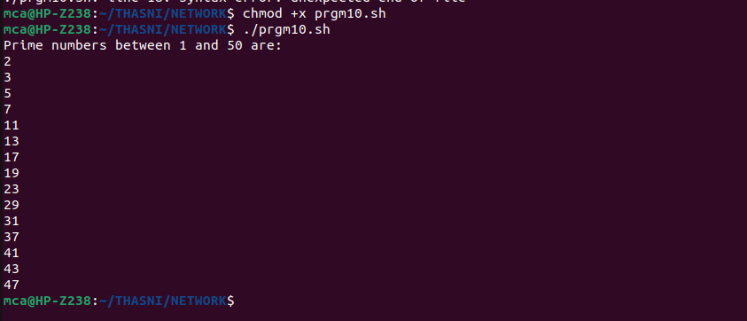

Program 11

Write a Shell program to find the sum of square of individual digits of a number.

#author:Thasni Noufal
echo "Enter a number: "
read number
sum=0
while [ $number -ne 0 ]
do
digit=$((number % 10))
sum=$((sum + digit * digit))
number=$((number / 10))
done
echo "The sum of the squares of the digits is $sum."

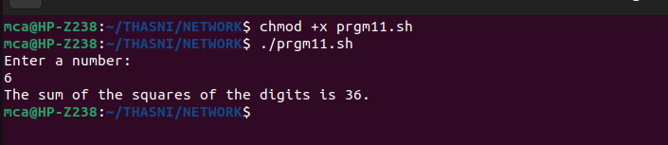

Program 12

Write a Shell program to count the number of vowels in a line of text.

#author:Thasni Noufal
echo "Enter a line of text:"
read line
vowel_count=0
for (( i=0; i<${#line}; i++ )); do
char=${line:i:1}
case $char in
[aeiouAEIOU])
vowel_count=$((vowel_count + 1))
;;
esac
done
echo "The number of vowels in the line of text is: $vowel_count"

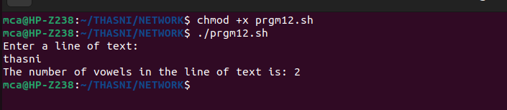

Program 13
Write a Shell program to display student grades.

INPUT_FILE="grades.txt"
if [[ ! -f "$INPUT_FILE" ]]; then
echo "Input file not found!"
exit 1
fi
declare -A grades
while read line; do
name=$(echo "$line" | cut -d ',' -f 1)
grade=$(echo "$line" | cut -d ',' -f 2)
grades["$name"]=$grade
done < "$INPUT_FILE"
for name in "${!grades[@]}"; do
echo "$name: ${grades[$name]}"
done

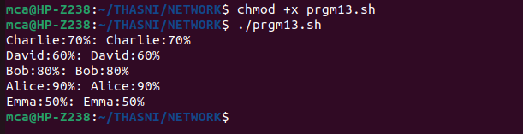

Program 14
Write a Shell program to find the smallest and largest numbers from a set of numbers.

#author:Thasni Noufal
NUMBERS=(5 3 8 1 9 4 7 2)
smallest=${NUMBERS[0]}
largest=${NUMBERS[0]}
for number in "${NUMBERS[@]}"; do
if (( number < smallest )); then
smallest=$number
fi
if (( number > largest )); then
largest=$number
fi
done
echo "Smallest number: $smallest"
echo "Largest number: $largest"

Program 15
Write a Shell program to find the smallest digit from a number.

#author:Thasni Noufal
echo "Enter a number:"
read number
smallest=${number:0:1}
for (( i=1; i<${#number}; i++ )); do
digit=${number:i:1}
if (( digit < smallest )); then
smallest=$digit
fi
done
echo "Smallest digit: $smallest"

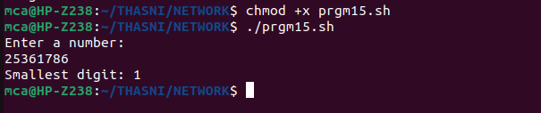

Program 16
Write a Shell program to find the sum of all numbers between 50 and 100, which are
divisible by 3 and not divisible by 5.

#author:Thasni Noufal

sum=0
for (( i=50; i<=100; i++ )); do
if (( i % 3 == 0 )) && (( i % 5 != 0 )); then
sum=$(( sum + i ))
fi
done
echo "Sum of numbers between 50 and 100, which are divisible by 3 and not divisible by 5:
$sum"

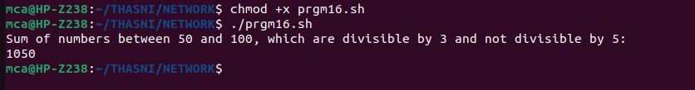

Program 17
Write a Shell program to find the second highest number from a set of numbers.

NUMBERS=(5 3 8 1 9 4 7 2)
highest=${NUMBERS[0]}
second_highest=${NUMBERS[0]}
for number in "${NUMBERS[@]}"; do
if (( number > highest )); then
second_highest=$highest
highest=$number
elif (( number != highest )) && (( number > second_highest )); then
second_highest=$number
fi
done
echo "Second highest number: $second_highest"

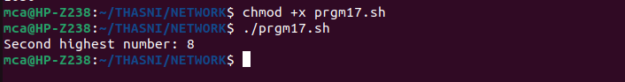

Program 18
Write a Shell program to find the sum of digits of a number using function.

function sum_of_digits {
local number=$1
local sum=0
while (( number > 0 )); do
sum=$(( sum + number % 10 ))
number=$(( number / 10 ))
done
echo "$sum"
}
echo "Enter a number:"
read number
result=$(sum_of_digits $number)
echo "Sum of digits of $number: $result"

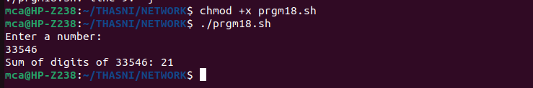

Program 19
Write a Shell program to print the reverse of a number using function.

function reverse_number {
local number=$1
local reverse=0
while (( number > 0 )); do
reverse=$(( reverse * 10 + number % 10 ))
number=$(( number / 10 ))
done
echo "$reverse"
}
echo "Enter a number:"
read number
result=$(reverse_number $number)
echo "Reverse of $number: $result"

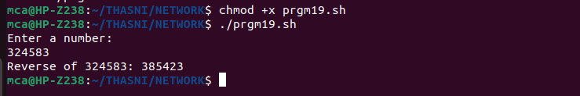

Program 20
Write a Shell program to find the factorial of a number using for loop.

echo "Enter a number:"
read number
factorial=1
for (( i=1; i<=number; i++ )); do
factorial=$(( factorial * i ))
done
echo "Factorial of $number: $factorial"

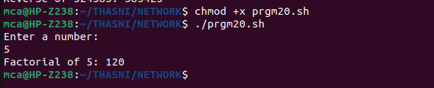

Program 21
Write a Shell program to generate Fibonacci series.

echo "Enter the length of the Fibonacci series:"
read length
num1=0
num2=1
echo -n "$num1 $num2 "
for (( i=2; i<length; i++ )); do
next=$(( num1 + num2 ))
echo -n "$next "
num1=$num2
num2=$next
done
echo ""

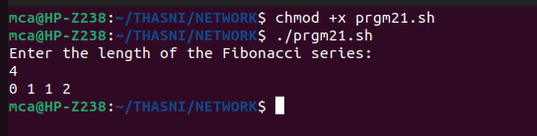

Program 22
Write a shell script, which receives two filenames as arguments. It checks whether the two
files contents are same or not. If they are same then second file is deleted.

#!/bin/bash

if [ $# -ne 2 ]; then
echo "Usage: $0 file1 file2"
exit 1
fi
if cmp -s "$1" "$2"; then
echo "The contents of $1 and $2 are the same. Deleting $2..."
rm "$2"
else
echo "The contents of $1 and $2 are different."
Fi

Program 23
Write a Menu driven Shell script that Lists current directory, Prints Working Directory,
displays Date and displays Users logged in

#!/bin/bash
while true
do
clear
echo "Menu:"
echo "1. List current directory"
echo "2. Print working directory"
echo "3. Display date"
echo "4. Display users logged in"
echo "5. Exit"

read -p "Enter your choice: " choice
case $choice in
1)
ls -l
read -p "Press enter to continue"
;;
2)
pwd
read -p "Press enter to continue"
;;
3)
date
read -p "Press enter to continue"
;;
4)
who
read -p "Press enter to continue"
;;
5)
exit 0
;;
*)
echo "Invalid choice. Press enter to try again"
read
;;
esac
done

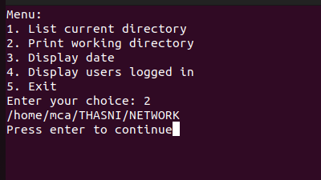

Program 24
Shell script to check executable rights for all files in the current directory, if a file does not
have the execute permission then make it executable.

for file in *; do
if [[ ! -x "$file" ]]; then
chmod +x "$file"
echo "Made $file executable"
fi
done

Program 25
Write a Shell program to generate all combinations of 1, 2, and 3 using loop.

#!/bin/bash
for i in 1 2 3
do
for j in 1 2 3
do
for k in 1 2 3
do
echo "$i $j $k"
done
done
done

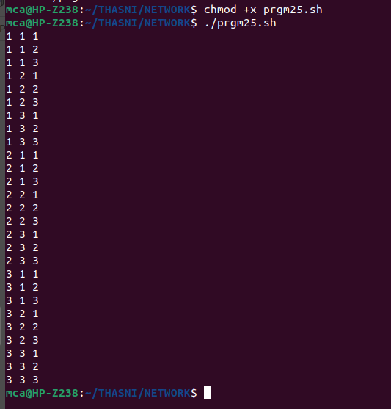

Program 26
Write a Shell program to create the number series.
1
2 3
4 5 6
7 8 9 10

#!/bin/bash
num=1
row=1
while [ $row -le 4 ]; do
for (( i=1; i<=$row; i++ )); do
echo -n "$num "
num=$((num+1))
done
echo ""
row=$((row+1))
done

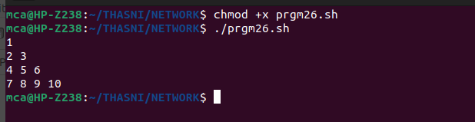

Program 27
Write a Shell program to create Pascal’s triangle.

#!/bin/bash
function binom {
if [ $2 -eq 0 ] || [ $2 -eq $1 ]; then
echo 1
else
echo $(( $(binom $(($1-1)) $(($2-1))) + $(binom $(($1-1)) $2) ))
fi
}
echo "Enter the number of rows in Pascal's triangle: "
read rows
for (( i=0; i<$rows; i++ )); do
for (( j=0; j<=$i; j++ )); do
val=$(binom $i $j)
echo -n "$val "
done
# Move to next row
echo ""
done

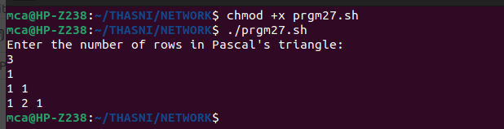

Program 28
Write a Decimal to Binary Conversion Shell Script

#!/bin/bash
# Prompt the user for the decimal number to convert
echo "Enter a decimal number: "
read decimal
# Convert the decimal number to binary
binary=""
while [ $decimal -gt 0 ]; do
remainder=$((decimal % 2))
binary="$remainder$binary"
decimal=$((decimal / 2))
done
# Print the binary number
echo "The binary equivalent is: $binary"

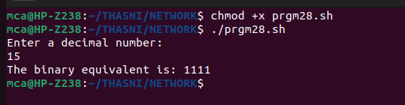

Program 29
Write a Shell Script to Check Whether a String is Palindrome or not

#!/bin/bash
# Prompt the user for the string to check
echo "Enter a string: "
read string
# Reverse the string
reverse=$(echo $string | rev)
# Check if the string is equal to its reverse
if [ "$string" == "$reverse" ]; then
echo "$string is a palindrome."
else
echo "$string is not a palindrome."
fi

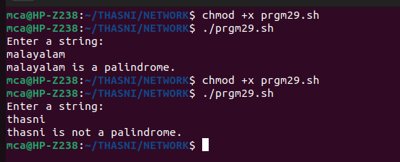

Program 30
Write a shell script to find out the unique words in a file and also count the occurrence of
each of these words.

echo "Enter the filename:"
read filename

if [ ! -f "$filename" ]; then
echo "File not found!"
exit 1
fi

unique_words=$(awk '{ for (i=1; i<=NF; i++) print $i }' "$filename" | sort | uniq -c)

echo "Unique words and their occurrences in $filename:"
echo "$unique_words"

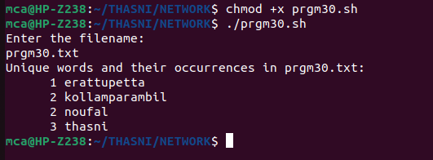

Program 31
Write a shell script to get the total count of the word “Linux” in all the “.txt” files and also
across files present in subdirectories.

#!/bin/bash
# Set the search directory
search_dir="."
# Find all ".txt" files in the search directory and its subdirectories
files=$(find "$search_dir" -type f -name "*.txt")
# Initialize the count
count=0
# Loop through each file and count the occurrences of "Linux"
for file in $files; do
occurrences=$(grep -o "Linux" "$file" | wc -l)
count=$((count + occurrences))
done

# Print the total count
echo "Total count of 'Linux' in all .txt files: $count"

Program 32
Write a shell script to validate password strength. Here are a few assumptions for the
password string.
Length – minimum of 8 characters.Contain both alphabet and number.
Include both the small and capital case letters.

#!/bin/bash
read -p "Enter your password: " password
# Check if password is at least 8 characters long
if [[ ${#password} -lt 8 ]]; then
echo "Password length must be at least 8 characters."
exit 1
fi
# Check if password contains both alphabet and number
if ! [[ "$password" =~ [A-Za-z]+[0-9]+ ]]; then
echo "Password must contain both alphabet and number."
exit 1
fi
# Check if password includes both small and capital case letters
if ! [[ "$password" =~ [a-z]+ ]] || ! [[ "$password" =~ [A-Z]+ ]]; then
echo "Password must include both small and capital case letters."
exit 1
fi
echo "Password is valid."

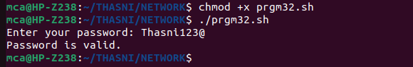

Program 33
Write a shell script to print the count of files and subdirectories in the specified directory.

echo "Enter directory path: "
read directory
num_files=$(find $directory -type f | wc -l)
num_directories=$(find $directory -type d | wc -l)
echo "Number of files: $num_files"
echo "Number of directories: $num_directories"

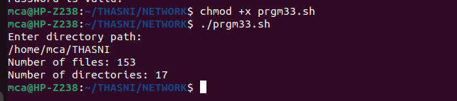

Program 34
Write a shell script to reverse the list of strings and reverse each string further in the list.

#!/bin/bash
my_list=("string1" "string2" "string3" "string4")
# Reverse the order of the list
my_list=($(echo "${my_list[@]}" | tr ' ' '\n' | tac | tr '\n' ' '))
# Reverse each string in the list
for i in "${!my_list[@]}"
do
my_list[$i]=`echo ${my_list[$i]} | rev`
done
# Print the reversed list of strings
echo "${my_list[@]}"

